**Activity1:**

**Code:**

/*

Name: Abdullah Mehdi

Registration No: SP21-BCS-OO2

Activity 1: finding average

*/

public class Activity1{

public static void main(String[] args) {

int num1 = 125; // Declaring num1

int num2 = 28; // Declaring num2

int num3 = -25; // Declaring num3

int average = (num1 + num2 + num3) / 3;

System.out.println("num1: " + num1);

System.out.println("num2: " + num2);

System.out.println("num3: " + num3);

System.out.println("The average of num1, num2 and num3 is: " + average);

}

}

**Output:**

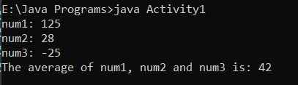

**Activity1:**

**Code:**

/*

Name: Abdullah Mehdi

Registration No: SP21-BCS-OO2

Activity 2: Arranging Syntex of Code

*/

import java.util.Scanner;

public class Activity2{

public static void main(String[] args) {

Scanner console = new Scanner(System.in);

System.out.print("Enter the width: ");

int width = console.nextInt();

System.out.println();

System.out.print("Enter the length: ");

int length = console.nextInt();

System.out.println();

int area = length * width;

System.out.println("Area = " + area);

int perimeter = 2 * (length + width);

System.out.println("Perimeter = " + perimeter);

}

}

**Output:**

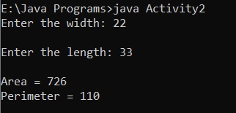

**Activity3:**

**Code:**

/*

Name: Abdullah Mehdi

Regstration No: SP21-BCS-OO2

Activity 3: Amount Conversion

*/

import java.util.Scanner;

public class Activity3{

public static void main(String[] args) {

Scanner input = new Scanner(System.in);

System.out.print("Enter the amount as decimal: ");

double amount = input.nextDouble();

System.out.println();

double cents = amount * 100;

System.out.println();

double dollars = amount / 100; // Fidning number of cents

cents = cents % 100;

System.out.println("Number of cents: " + cents);

System.out.println();

double noOfQuaters = cents / 25; // Fidning number of Quaters

double remainingCents = cents % 25;

System.out.println("Number of Quaters: " + noOfQuaters);

System.out.println();

double noOfDimes = remainingCents / 10; // Fidning number of Dimes

remainingCents = remainingCents % 10;

System.out.println("Number of Dimes: " + noOfDimes);

System.out.println();

double noOfNickels = remainingCents / 5; // Fidning number of Nickels

remainingCents = remainingCents % 5;

System.out.println("Number of Nickels: " + noOfNickels);

System.out.println();

System.out.println("Number of pennes: " + remainingCents); // Fidning number of pennes

}

}

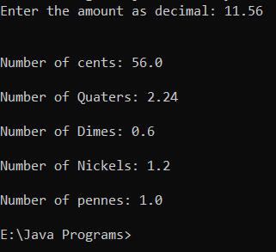**Output:**

**Activity4:**

**Code:**

/*

Name: Abdullah Mehdi

Regstration No: SP21-BCS-OO2

Activity 4: Counting Number of Apples

*/

import java.util.Scanner;

public class Activity4{

public static void main(String[] args) {

Scanner input = new Scanner(System.in);

System.out.print("Enter number of Students: "); // Obtaining Number of Students

int n = input.nextInt();

System.out.print("Enter number of Apples: "); // Obtaining Number of Apples

int k = input.nextInt();

int distribution = k / n;

System.out.println("Number of Apples distributed to each student is: " + distribution); // Distributing Apples

int remaining = k % n;

System.out.print("The remaining Apples in the basket are: " + remaining); // Remaining Apples

}

}

Output:

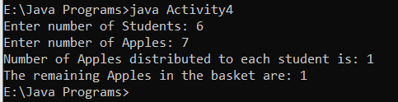

**Activity 5**

**Code:**

/*

Name: Abdullah Mehdi

Regstration No: SP21-BCS-OO2

Activity 5: Counting Number of Desks

*/

import java.util.Scanner;

public class Activity5{

public static void main(String[] args) {

Scanner input = new Scanner(System.in);

System.out.println("Enter number of Students of class 1: "); // Obtaining number of students of class 1

int class1 = input.nextInt();

int class1Desks = class1 / 2; // Calculating number of Desks of Class 1

System.out.println("Class 1 desks" + class1Desks);

System.out.println("Enter number of Students of class 2: "); // Obtaining number of students of class 2

int class2 = input.nextInt();

int class2Desks = class1 / 2; // Calculating number of Desks of Class 2

System.out.println("Class 1 desks" + class2Desks);

System.out.println("Enter number of Students of class 3: "); // Obtaining number of students of class 3

int class3 = input.nextInt();

int class3Desks = class3 / 2; // Calculating number of Desks of Class 3

System.out.println("Class 1 desks" + class3Desks);

int totalNumberOfStudents = class1 + class2 + class3;

System.out.println("Total Number Of Students are: " + totalNumberOfStudents); // Calculating total number of Students

int desksRequiredTotal = class2Desks + class2Desks + class3Desks; // Calculating total number of desks

System.out.println(desksRequiredTotal);

}

}

Output:

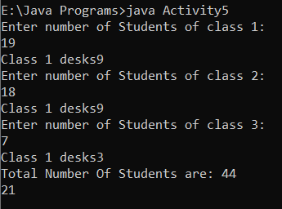

**Activity 6**

**Code:**

/*

Name: Abdullah Mehdi

Regstration No: SP21-BCS-OO2

Activity 6: number of hours

*/

import java.util.Scanner;

public class Activity6{

public static void main(String[] args) {

Scanner input = new Scanner(System.in);

System.out.print("Enter the number of minutes: "); // Calculating number of minutes

double minutes = input.nextDouble();

double hours = minutes / 60;

System.out.println("Number of hours are: " + (int)hours); // Calculating number of hours

double minutesAfter = minutes % 60;

System.out.println("Number of minutes are: " + minutesAfter);

System.out.println("Number of hours and minutes are: " + (int) hours + ":" + (int) minutesAfter); // Giving output of hours and minutes separately

}

}

Output:

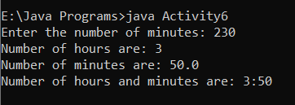

**Activity 7**

**Code:**

/*

Name: Abdullah Mehdi

Regstration No: SP21-BCS-OO2

Activity 7: Milk profit calculation

*/

import java.util.Scanner;

public class Activity7{

public static void main(String[] args) {

Scanner input = new Scanner(System.in);

double cartonPrice = 3.78;

double oneLitterMilk = 0.38; // Declaring prices of different products

double oneGallonMilk = 0.38 * 3.78;

double cartonProfit = 0.27;

System.out.print("Enter the total amount of milk (weigh) in gallons: "); // Calculating the weigh of milk in gallons

int amount = input.nextInt();

double noOfCartons = amount / cartonPrice;

System.out.println("No. of cartons producing milk are: " + (int) noOfCartons); // Calculating number of cartons

double price = noOfCartons * oneGallonMilk;

System.out.println("Cost of producing milk is $: " + price); // calculating cost of Milk

double profit = noOfCartons * cartonProfit;

System.out.print("Profit of producing milk is $: " + profit); // Calculating Profit

}

}

Output:

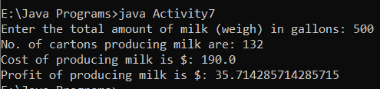

**Activity 8**

**Code:**

/*

Name: Abdullah Mehdi

Regstration No: SP21-BCS-OO2

Activity 8: Milk profit calculation

*/

import java.util.Scanner;

public class Activity8{

public static void main(String[] args) {

Scanner input = new Scanner(System.in);

double payPerHour = 15.50;

double totalTax = 14/100;

System.out.println("Enter the pay rate rate for an hour: "); // Obtaining pay rate in an hour

double payRate = input.nextDouble();

System.out.println("Enter the number of hours worked each week: "); // Obtaining number of hours worked in a week

int noOfHrs = input.nextInt();

double incomeBeforeTax = payRate * 35; // 35 = 5 weeks

System.out.println("Payment before tax $: " + (int) incomeBeforeTax); // Calclating money before tax

double incomeAfterTax = incomeBeforeTax * 0.625; // 0.625 includes all taxes

System.out.println("Payment Afters tax $: " + (int) incomeAfterTax); // Calclating money after tax

double incomeSchool = incomeBeforeTax * 1/100;

System.out.println("Payment After school supplies and Clothes $: " + (int) incomeSchool); // Calclating money after school tax

double incomeSavingFunds = incomeBeforeTax * 25/100;

System.out.println("Payment After saving Funds tax $: " + (int) incomeSavingFunds); // Calclating money after saving funds tax

double incomeAdditionalFunds = incomeBeforeTax * 0.125;

System.out.println("Payment After school tax $: " + (int) incomeAdditionalFunds);

}

}

Output:

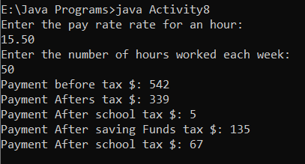

**Activity 9**

**Code:**

/*

Name: Abdullah Mehdi

Regstration No: SP21-BCS-OO2

Activity 9: Milk profit calculation

*/

import java.util.Scanner;

public class Activity9{

public static void main(String[] args) {

Scanner input = new Scanner(System.in);

int seatA = 20;

int seatB = 15;

int seatC = 10;

int seatD = 5;

System.out.println("Enter the number of seat A: "); // Obtaing number of seats of class A

int seatsA = input.nextInt();

int seatACost = seatsA * seatA;

System.out.println("Enter the number of seat B: "); // Obtaing number of seats of class B

int seatsB = input.nextInt();

int seatBCost = seatsB * seatB;

System.out.println("Enter the number of seat C: "); // Obtaing number of seats of class C

int seatsC = input.nextInt();

int seatCCost = seatsC * seatC;

System.out.println("Enter the number of seat D: "); // Obtaing number of seats of class D

int seatsD = input.nextInt();

int seatDCost = seatsD * seatD;

int income = seatACost + seatBCost + seatCCost + seatDCost;

System.out.println("The Toatl income is $: " + income);

}

}

Output:

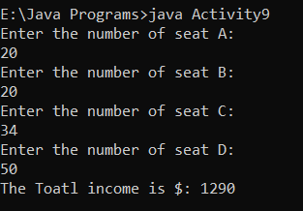

**Activity 10**

**Code:**

/*

Name: Abdullah Mehdi

Regstration No: SP21-BCS-OO2

Activity 9: index addition

*/

import java.util.Scanner;

public class Activity10{

public static void main(String[] args) {

Scanner input = new Scanner(System.in);

System.out.print("Enter a number between 0 and 1000: ");

int number = input.nextInt();

int lessThan10 = number % 10; // obtaining 1's

number /= 10;

int tens = number % 10; // obtaining 10's

number /= 10;

int hundreds = number % 10; // obtaining 100's

number /= 10;

int sum = hundreds + tens + lessThan10;

System.out.println("The sum of the digits is " + sum);

}

}

**Output:**

